A000-Asia-Viet Nam-Dong Son Drum-Heger type I-600 BCE

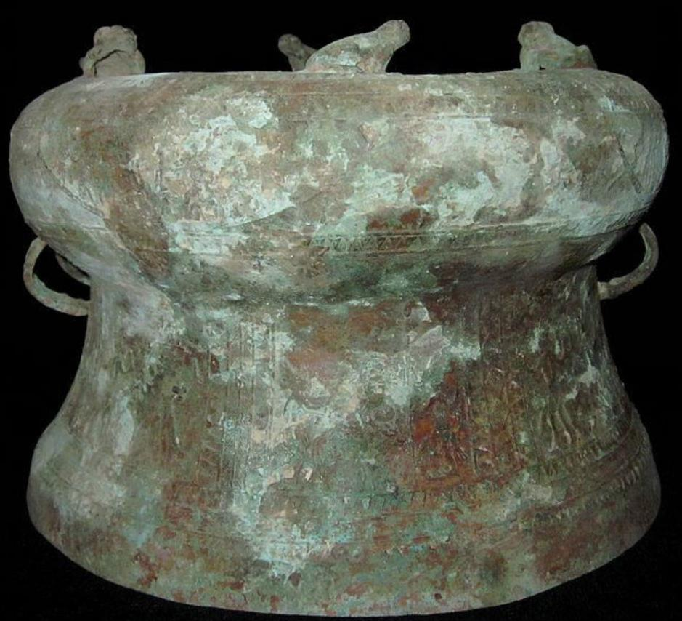

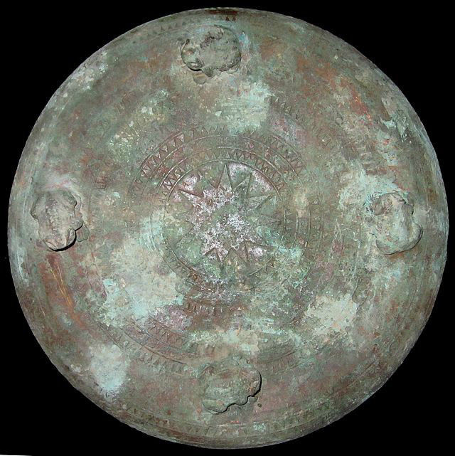 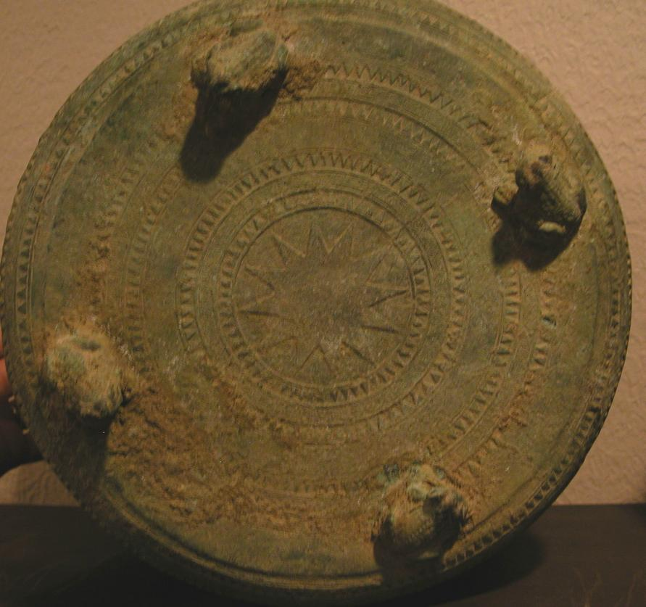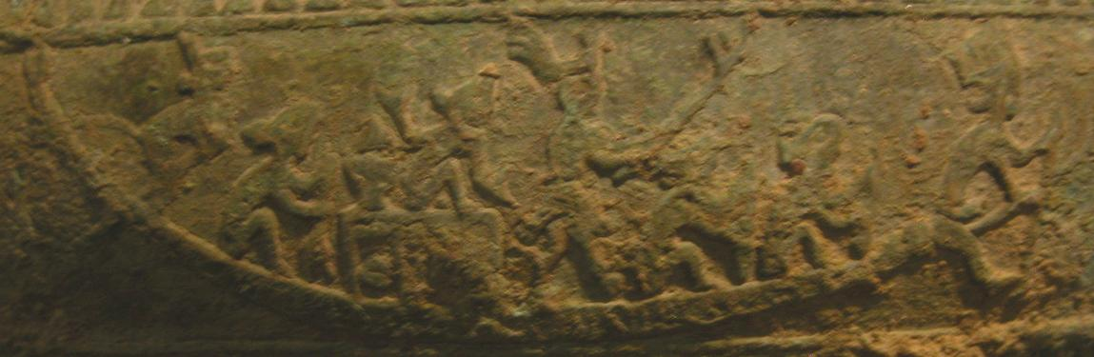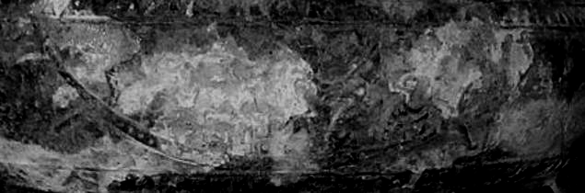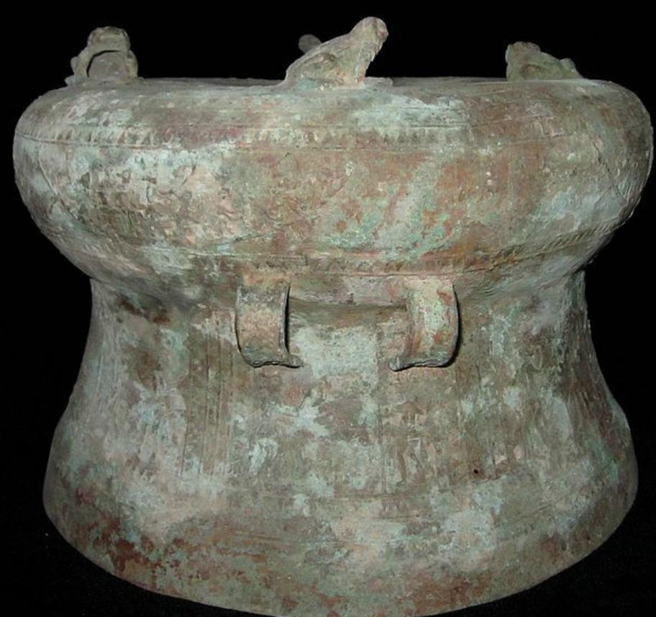

Case No.:

Accession No.

Heger 1 drums of the Dong Son culture were classified and divided into five chronological groups by the Vietnamese scholar Pham Huy Thong in 1990. The earliest, group A, comprises a set of large and intricately decorated drums. **Group B consists of smaller drums which almost universally have a group of waterbirds in flight as their key motif on the tympanum and the mantle designs.** **This particular drum is in this category.** Group C has a central panel on the tympanum made up of a row of plumed warriors placed inside another panel of waterbirds in flight. Toads line the tympanum's edge while the mantle was decorated with either patterns involving boats or geometric patterns (Higham 1996: 128).

LC Classification:

Date or Time Horizon: 600 BCE

Geographical Area: Vietnam

Map:

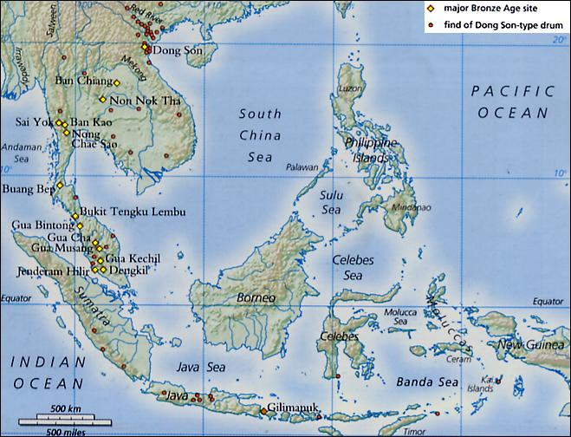

https://upload.wikimedia.org/wikipedia/en/2/2e/Dong_Son_bronze_drums.JPG

GPS Coordinates: Dong Son, Vietnam

Cultural Affiliation: Dong Don Bronze Culture

Medium: Bronze

**Dimensions**:   
**Weight:**

**Provenance**:

**Condition:**

**Discussion:**

**References:**

Higham, Charles. 1996. The Bronze Age of Southeast Asia. Cambridge World Archaeology. Cambridge: Cambridge University Press.

### Notes

1 Zhongguo Gudai Tonggu Yanjiuhui, Zhongguo gudai tonggu (The Ancient Bronze Drums of China) (Beijing: Wenwu Press, 1988), 8. Hereafter, ZGTY. According to this book, the numbers of bronze drums stored in various provinces and cities are as follows: Guangxi: 560; Guangdong: 230; Shanghai: 230; Yunnan: 160; Guizhou: 88; Beijing: 84; Sichuan:51; Hunan: 27; Shandong: 8; Hubei: 6; Zhejiang: 6; Liaoning: 4. The total number of bronze drums stored in China remained unchanged in 1995. See Shijie ribao (World Journal), "Nanfang tonggu wenhua yanjiu you chengguo" (Results have been achieved in the Study of the bronze drums of southern China), 13 January 1995, 11.

2 Nguyen Duy Hinh, "Bronze Drums in Vietnam," The Vietnam Forum 9 (1987): 4-5; Pham Huy Thong, Dong Son Drums in Vietnam, (Hanoi: The Vietnam Social Science Publishing House, 1990), 265. Some more Dong Son drums have been found in Vietnam since then. For example, in 1994, a Dong Son drum later named a Ban Khooc drum was found in Son La Province in northwestern Vietnam. Pham Quoc Quan and Nguyen Van Doan, "Trong Dong Son La" (The Son La Bronze Drum), Khao Co Hoc 1 (1996): 10.

3 Xu Songshi, Baiyue xiongfeng lingnan tonggu (The Masculine Spirit of the Hundred-Yue and the Bronze Drums of Southern China), Asian Folklore & Social Life Monographs 95 (Taibei: The Orient Cultural Service, 1977), 7-8.

4 Nguyen Duy Hinh, "Trong dong trong su sach" (The Bronze Drums in Historical Records), Khao Co Hoc 13 (1974): 18-20.

5 Jiang Tingyu, Tonggu shihua (History of the Bronze Drum) (Beijing, Wen Wu Press, 1982), 18.

6 For a comprehensive introduction to and list of Western archaeological works on the bronze drum see Pham Minh Huyen, Nguyen Van Huyen and Trinh Sinh, Trong Dong Son (The Dong Son Drums) (Hanoi: Nha Xuat Ban Khoa Hoc Xa Hoi, 1987), 12-14, 306-309; ZGTY, 10-12.

7 Wenwu Bianji Weiyuanhui (Editorial Board of Cultural Relics), Wenwu kaogu gongzuo shinian: 1979-1989 (A Decade of Work in the Field of Cultural Relics and Archaeology: 1979-1989) (Beijing, Wenwu Press, 1990), 376, 380.

8 Pham, Nguyen and Trinh.

9 Pham, Nguyen and Trinh, 19-21; ZGTY, 10-11.

10 Pham Huy Thong, Dong Son Drums in Vietnam,, 4.

11 Pham, Nguyen and Trinh, 21-22.

12 Tran Manh Phu, "Thu chia nhom nhung trong dong loai I Hego phat hien o Viet Nam" (The Classification of Heger's Type I Bronze Drums Discovered in Vietnam), Khao Co Hoc 13 (1974): 83-94.

13 Luu Tran Tieu and Nguyen Minh Chuong, "Nien dai trong Dong Son" (The Dating of the Dong Son Drums), Khao Co Hoc 13 (1974): 117-121.

14 Chu Van Tan, "Nien dai trong Dong Son" (The Dating of the Dong Son Drum), Khao Co Hoc 13 (1974): 106-116.

15 Diep Dinh Hoa and Pham Minh Huyen, "Ve viec chia loai trong loai I Hego va moi quan he giua loai trong nay voi cac loai trong khac" (The Classification of Heger's Type I Bronze Drums and Its Relationship with Other Types of Bronze Drum), Khao Co Hoc 13 (1974): 126-134.

16 Pham, Nguyen and Trinh, 23-34, 120-123.

17 For example, Heger's Type II were mostly found in southern China and among the Muong minority of Vietnam; Type III existed in Burma and southern China but not in Vietnam; Type IV were believed to exist in southern China only. Pham Huy Thong, "Trong Dong" (The Bronze Drum), Khao Co Hoc 13(1974): 9-11. It was reported in the 1980s that 14 Type III drums and 6 Type IV drums had been found in Vietnam. Nguyen Duy Hinh, 4.

18 ZGTY, 12.

19 Wen You, Gu tonggu tulu (Collected Pictures of the Ancient Bronze Drums) (Beijing: Zhongguo gudian yishu Press, 1957), n.p.; Huang Zengqing, "Guangxi tonggu chutan" (The Bronze Drums of Guangxi), Kaogu 11 (1964), 578-588; Hong Sheng, "Guangxi gudai tonggu yanjiu" (The Ancient Bronze Drums in Guangxi), Kaogu Xuebao 1 (1974): 45-90.

20 Li Weiqing, "Zhongguo nanfang tonggu de fenlei he duandai" (The Classification and Dating of the Bronze Drums of Southern China), Kaogu 1 (1979): 66-78.

21 Wang Ningsheng, "Shilun zhongguo gudai tonggu" (On the Ancient Bronze Drums of China), in Minzu kaoguxue lunji (Collected Eaasys on Ethnoarchaeology) (Beijing: Wenwu Press, 1989), 277-306.

22 Li Weiqing, 66-78.

23 Shi Zhongjian, "Ancient Bronze Drums," China Pictorial 10 (1983): 24-25.

24 Wen You worked in Sichuan as a University professor for more than ten years before he moved to Beijing in the mid-1950s. He wrote in 1956 that he first became interested in the bronze drum when he saw a beautiful bronze drum in Hanoi more than a decade earlier. Wen You, preface.

25 Shi Zhongjian, "Shizheng Yue yu Luoyue chuzi tongyuan" (On the Common Origin of the Yue [Viet] and Luoyue [Lac Viet)], in Baiyue minzushi lunji, (Beijing: China Social Science Press, 1982), 203.

26 Shijie ribao, 13 January 1995, 11.

27 ZGTY, Plate IX.

28 Fan Chengda, a scholar-official of the Song Dynasty (960-1279 AD) first suggested that the bronze drum was invented by Ma Yuan. A scholar in the Ming dynasty (1368-1644) first recorded that the big bronze drum was invented by Ma Yuan, and the small one by Zhuge Liang. F. Hirth tried to prove these stories in two articles published in 1898 and 1904. Zheng Shixu (Cheng Shih-hsu), Tonggu kaolue (A Study of the Bronze Drum) (Shanghai: Shanghai Museum, 1936), 3-5, 14, 33-37.

29 Nguyen Duy Hinh, "Ve guan diem cua mot so hoc gia Trung Quoc nghien cuu trong dong nguoi Viet" (A Review of the Views of Some Chinese Scholars on the Bronze Drums of the Vietnamese People), Khao Co Hoc 4 (1979): 17-19.

30 Nguyen Duy Hinh, "Ve guan diem," 21; Chu Van Tan, "Phai chang ho da tim thay trong X?" (Have They Discovered Drum X?), Khao Co Hoc 9 (1982): 33.

31 Pham Huy Thong, Dong Son Drums in Vietnam, 269.

32 Pham Huy Thong, Dong Son Drums in Vietnam, 210.

33 Tong Enzheng, "Shilun zaoqi tonggu" (On the Early Bronze Drums), in Zhongguo xinan minzu kaogu lunwenji (Collected Essays on the Ethnoarchaeology of Southwestern China) (Beijing: Wenwu Press, 1990), 163-185.

34 Nyuyen Van Huyen, "Tu chia loai nhom den tim hieu nien dai va que huong cua trong dong co" (From the Classification and Sub-classification of the Ancient Bronze Drums to the Understanding of their Dating and Origins), Khao Co Hoc 13 (1974), 101; Chu Van Tan, "Nien dai trong Dong Son," 114.

35 Diep Dinh Hoa and Pham Minh Huyen, 131.

36 Luu Tran Tieu and Nguyen Minh Chuong, 119.

37 Pham, Nguyen and Trinh, 216-217.

38 ZGTY, 110.

39 Wang Dadao, "Yunnan qingtong wenhua jichi yu Yuenan Dongshan wenhua, Taiguo Banching wenhua de guanxi" (The Bronze Culture of Yunnan and its relations with the Dong Son Culture of Vietnam and the Ban Chiang Culture of Thailand), Kaogu 6 (1990): 536, 540.

40 Chu Van Tan, "Phai chang ho da tim thay trong X?," 30, 32.

41 Dao Tu Khai, "Chim Lac hay con co? Ngoi sao hay mat troi?" (Lac Bird or Heron? Star or Sun?), Khao Co Hoc 14 (1974 ): 27.

42 Dao Tu Khai, 27.

43 Vu The Long, "Hinh va tuong dong vat tren trong va cac do dong Dong Son" (The Motifs and Figurines of Animals on Drums and Other Dongsonian Bronze Artifacts), Khao Co Hoc 14 (1974): 9.

44 Dao Tu Khai, 28-29.

45 ZGTY, 157.

46 ZGTY, 233.

47 Wen You, n.p.

48 ZGTY, 160-161.

49 Schafer Edward, The Vermilion Bird, (Berkeley: University of California Press, 1967), 254.

50 Vu The Long, 17.

51 Pham Huy Thong, Dong Son Drums in Vietnam, 268.

52 Pham Huy Thong, Dong Son Drums in Vietnam, 154.

53 Chen Guoqiang, Jiang Binzhao, Wu Mianqi, and Xing Tucheng, eds., Baiyue minzu shi (A History of the Hundred-Yue) (Beijing: China Social Science Press, 1988), 335.

54 Tong Enzheng, 178.

55 Feng Hanji, "Yunnan jinning chutu tonggu yanjiu" (A Study of the Bronze Drums of Jinning, Yunnan), Wen Wu 1 (1974): 56-58.

56 Ling Chunsheng, "Ji benxiao er tonggu jianluan tonggu de qiyuan he fenbu" (On the Two Bronze Drums Stored at National Taiwan University and the Origin and Distribution of the Bronze Drums), in Ling Chunsheng, ed., Zhongguo bianjiang yu huan taipingyang wenhua (The Culture of Chinese Border Areas and the Pacific), Vol. I, (Taipei: Lianjing chuban sheye gongsi, 1979), 542.

57 ZGTY, 175-181.

58 Pham, Nguyen and Trinh, 239.

59 Dao Tu Khai, 30.

60 ZGTY, 151.

61 ZGTY, 152.

62 ZGTY, 154.

63 Nguyen Duy Hinh, "Ve guan diem," 23.

64 Tran Quoc Vuong, "Trong dong va tam thuc Viet co" (The Bronze Drum and the Mentality of the Ancient Viet People), Khao Co Hoc 3 (1982): 25; Dao Tui Khai, 28-29.

65 ZGTY, 127-129.

66 Wang Ningsheng, 305; Tong Enzheng, 181.

67 Tong Enzheng, 173-174.

68 Shi Zhongjian, "Shizheng Yue yu Luoyue chuzi tongyuan," 194.

69 Pham Huy Thong, "Trong Dong" (The Bronze Drum), Khao Co Hoc 13 (1974), 9.

70 Phan Huy Thong, Dong Son Drums in Vietnam, 262.

71 Phan Huy Thong, Dong Son Drums in Vietnam, 264.

72 Cac Vua Hung da co cong dung nuoc..., Tap luan van ky niem 30 nam nhay Bac Ho den tham Den Hung: 19-9-1954--19-9-1984 (The Hung Kings have contributed to building our nation) (Vinh Phu: So Van Hoa-Thong Tin Vinh Phu, 1985), 133.

73 Luo Xianglin, Zhongxia xitong zhi Baiyue (The Hundred-Yue as a Branch of the Chinese Race) (Chongqing: Duli Press, 1943), 1-2; Xu Songshi, 96-97.

74 For example, Wen You lamented that traditional Chinese scholars before the Qing dynasty seldom paid serious attention to the bronze drum because it did not have inscriptions and was believed to have been made by "barbarians." During the Qing dynasty, however, more attention was paid to the bronze drum and several books were produced. Wen attributed this to the general increase in popularity of the Ma Yuan and Zhuge Liang myth after the Song dynasty. Wen You, preface.

75 Wen You, preface.

76 Li Weiqing and Xi Keding, "Shi tan zhong guo nan fang tong gu de zu shu" (An Inquiry into the Ethnic Affiliations of the Bronze Drums of Southern China), in Xinan minzu yanjiu (Studies on the Ethnic Groups of Southwestern China) (Chengdu: Sichuan Minzu Press, 1983), 427.

77 Charles Higham, The Bronze Age of Southeast Asia (Cambridge: Cambridge University Press, 1996), 134.

78 ZGTY, 10-11; Phan Huy Thong, Dong Son Drums in Vietnam,, 263-264.

